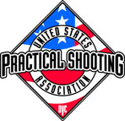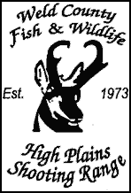
Hosts
12th Annual
“Rocky Mountain 300”

JUNE 3th – JUNE 5st, 2015
Weld County Fish and Wildlife
8 Miles East/1 Mile South of Ault, CO

A USPSA Level 1 Pistol Match
5 Stages + Chrono- 300+ Rounds
Cash Awards-Trophies-Random Prizes
Cash Payback to class and division winners

Match Fee- $85.00 Juniors- $40.00
Match Fee after APRIL 25th- $100.00 Juniors- $65.00
Lunch included in match fee
Camping Available at Range
Make Checks payable to: Weld County Fish & Wildlife

2-day shooting format (pick one)
FRIDAY 8:00am limited to 60 competitors
SATURDAY 8:00am LIMITED to 80 competitors

Shoot-offs Sunday 8:00am- 100% Cash Payback
Shoot-offs will be handicapped according to class
Entry Fee- $10.00

Match Director / RANGE MASTER: Jerry Westcott
jerry40gm@gmail.com
(970) 532-2146 / cell (303) 903-4304

